Anthony Rosenblum

EELE 317

11/7/2018

Lab 8 Report

**Introduction:**

In this lab I built a single transistor BJT common emitter amplifier. After constructing the system I used different measurement techniques to calculate the gain, input and output impedances, and frequency response.

**Pre-lab:**

1. Data from Lab 6

* Bac = 144
* Bdc = 142
* Va = 270 V

2) Hand Calculations

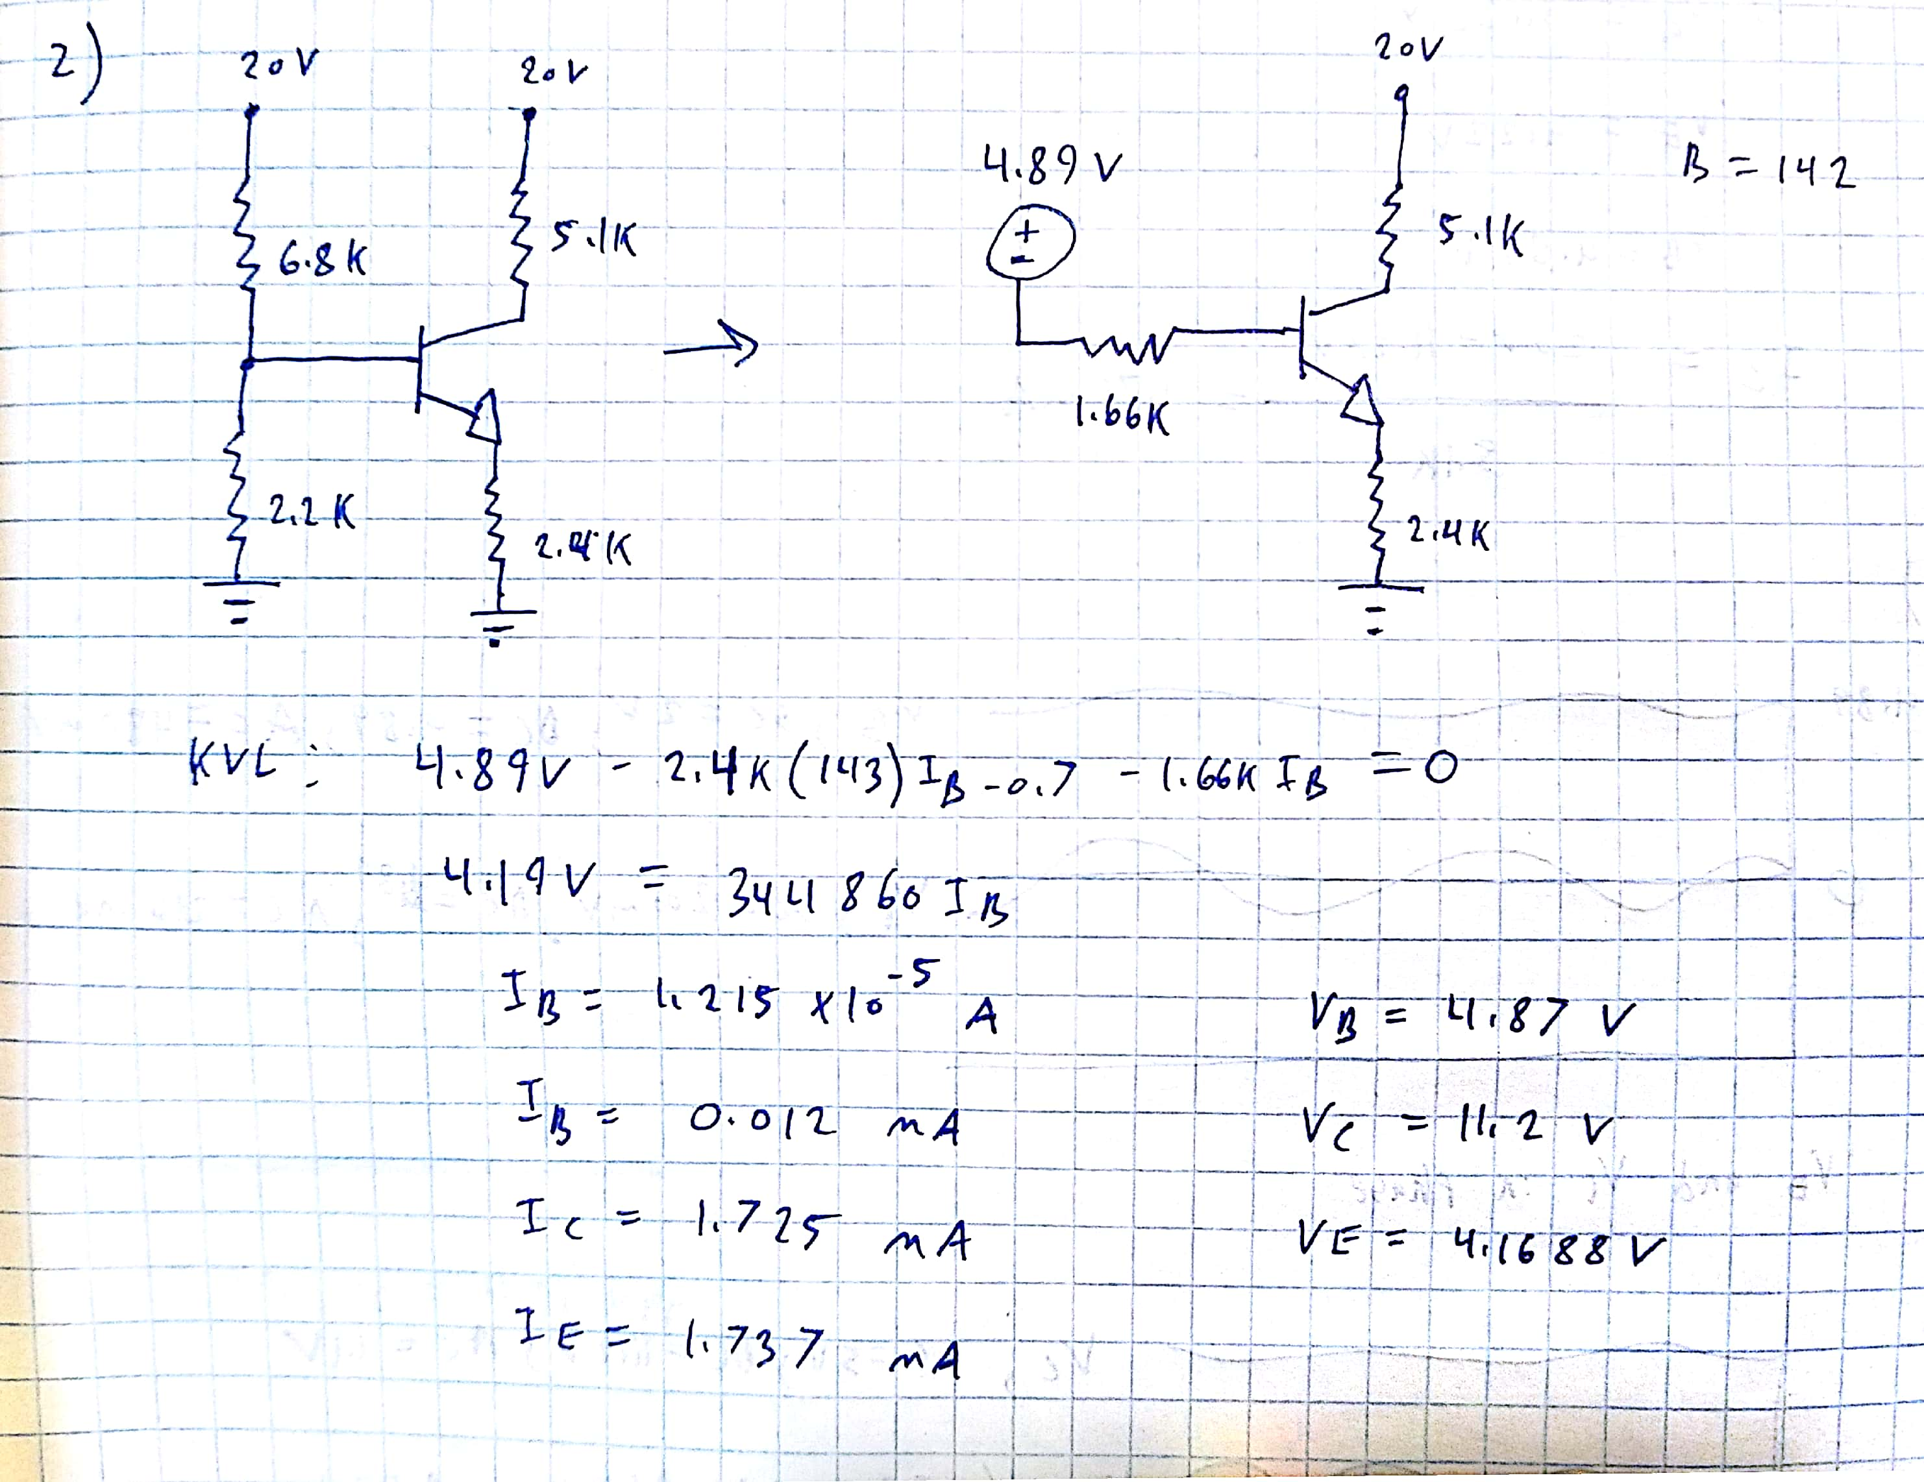

DC Bias Conditions:

Vb = 4.87 V Ib = 0.012 mA

Vc = 11.2 V Ic = 1.725 mA

Ve = 4.17 V Ie = 1.737 mA

3) SPICE Simulations

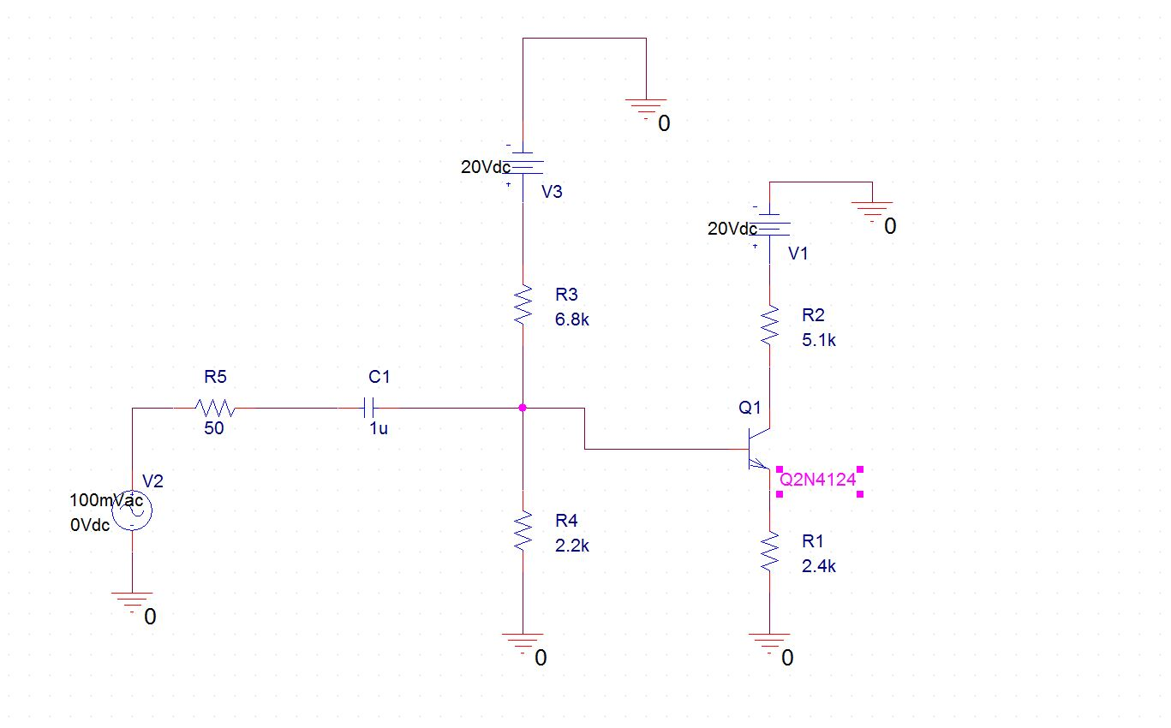

**Experiments:**

Experiment 1:

* 1. Vc = 11.28V, Ve = 4.22 V, Vb = 4.89 V

Ic = = 1.71 mA

1. Using 200 mVpp input waveform

a)

|  |  |  |  |
| --- | --- | --- | --- |
| Signal | DC value | AC variation pp | Phase |
| V1 | 4.89 V | 216 mV | 0 radians |
| Vb | 4.89 V | 480 mV | 0 radians |
| Vc | 11.2 V | 1.1V | pi radians |
| Ve | 4.2V | 320 mV | 0 raians |

V1, Vb, and Ve are all in phase. Vc is offset by a phase shift of pi radians, this signal observes a peak when the other signals are at a minimum.

DC Conditions Comparison:

|  |  |  |
| --- | --- | --- |
| Quantity | Calculations | Measurements |
| Ic | 1.725 mA | 1.71 mA |
| V1 | DNE | 4.89 V |
| Vb | 4.87 V | 4.89 V |
| Vc | 11.20 V | 11.20 V |
| Ve | 4.17 V | 4.20 V |

There is no significant variation between the DC pre-lab calculations and multimeter/scope measurements.

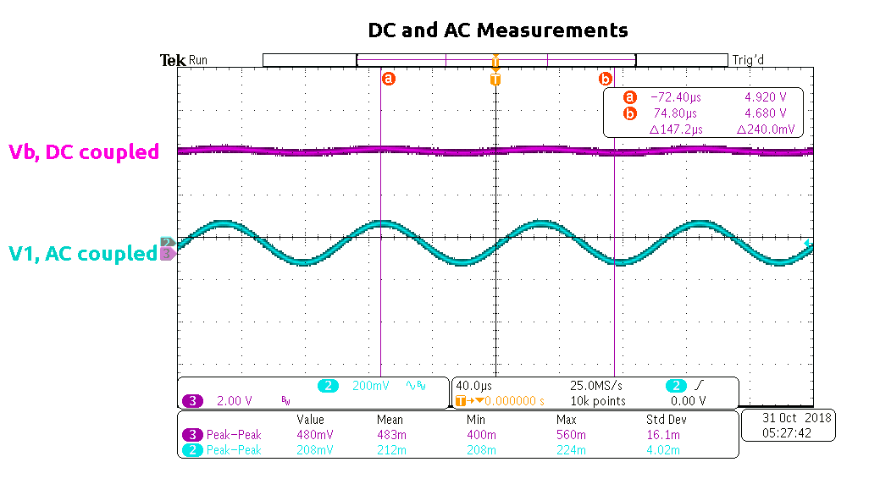

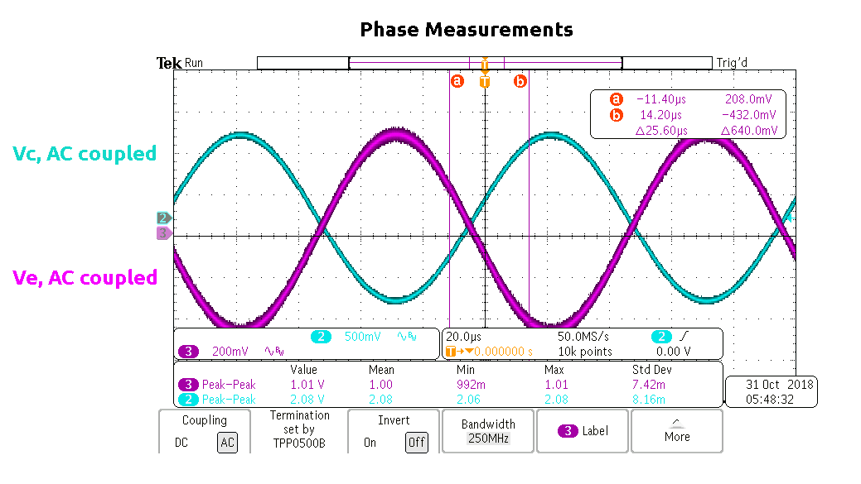

b)

|  |  |  |  |  |
| --- | --- | --- | --- | --- |
| F (hz) | V1 (mv AC) | Vb (mv AC) | Vc (mv AC) | Ve (mv AC) |
| 10 | 32 | 64 | 66 | 75 |
| 50 | 100 | 130 | 210 | 140 |
| 100 | 150 | 180 | 320 | 190 |
| 200 | 184 | 220 | 390 | 220 |
| 500 | 200 | 230 | 420 | 240 |
| 1k | 200 | 235 | 425 | 240 |
| 2k | 200 | 235 | 425 | 240 |
| 5k | 205 | 235 | 427 | 240 |
| 10k | 205 | 235 | 422 | 236 |

Gain:

|  |  |  |
| --- | --- | --- |
| F(hz) | Vc/V1 | Ve/V1 |
| 10 | 2.06 | 2.34 |
| 50 | 2.10 | 1.40 |
| 100 | 2.13 | 1.27 |
| 200 | 2.12 | 1.20 |
| 500 | 2.10 | 1.20 |
| 1k | 2.13 | 1.20 |
| 2k | 2.13 | 1.20 |
| 5k | 2.08 | 1.17 |
| 10k | 2.06 | 1.15 |

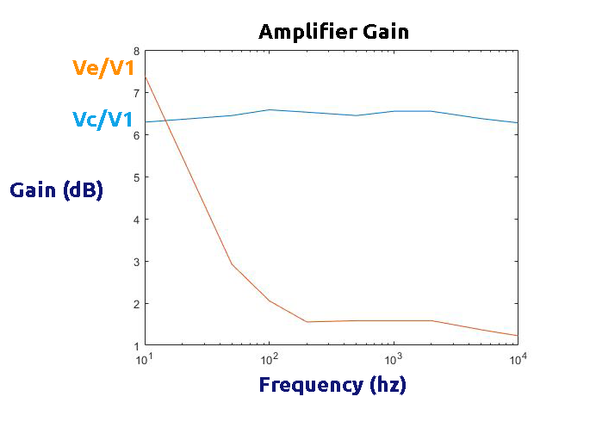

c) When viewing the output waveforms at V1 = 1, 2, and 4 Vpp I observed the expected growth with no distortion. When reaching V1 =10 Vpp I began to notice some clipping in the output waveform. This is likely due to the transistor leaving the active region once the swing in voltage at the collector becomes great enough.

V1 = 1V

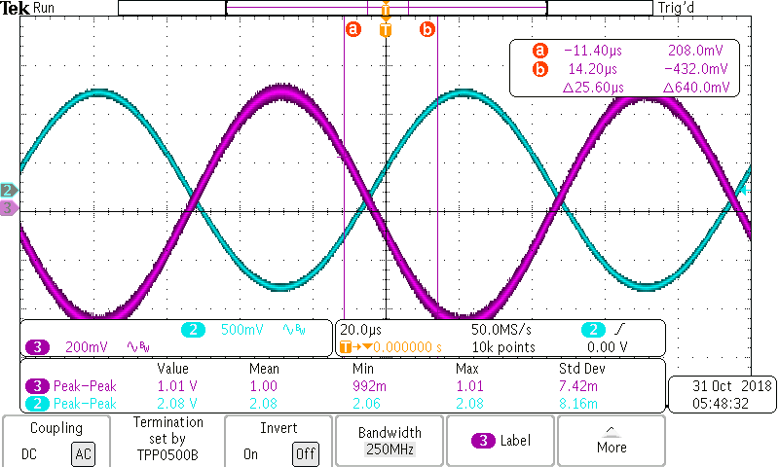

V1 = 2V

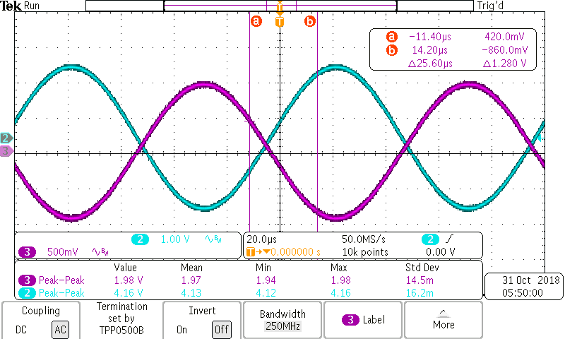

V1 = 4V

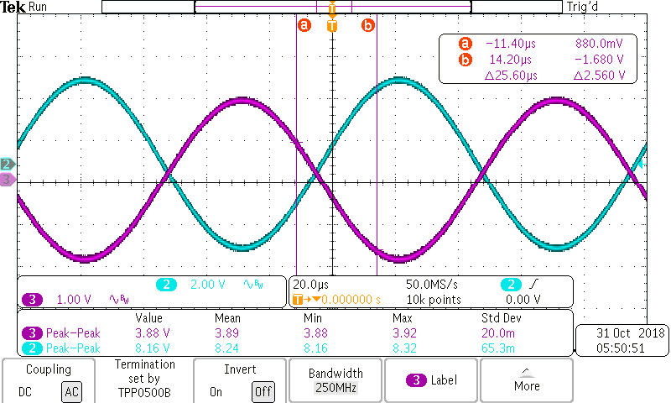

Experiment 2)

Part 1)

At 10khz, Vin = 200 mVpp

Vx = 206 mVpp

Vy = 124 mVpp

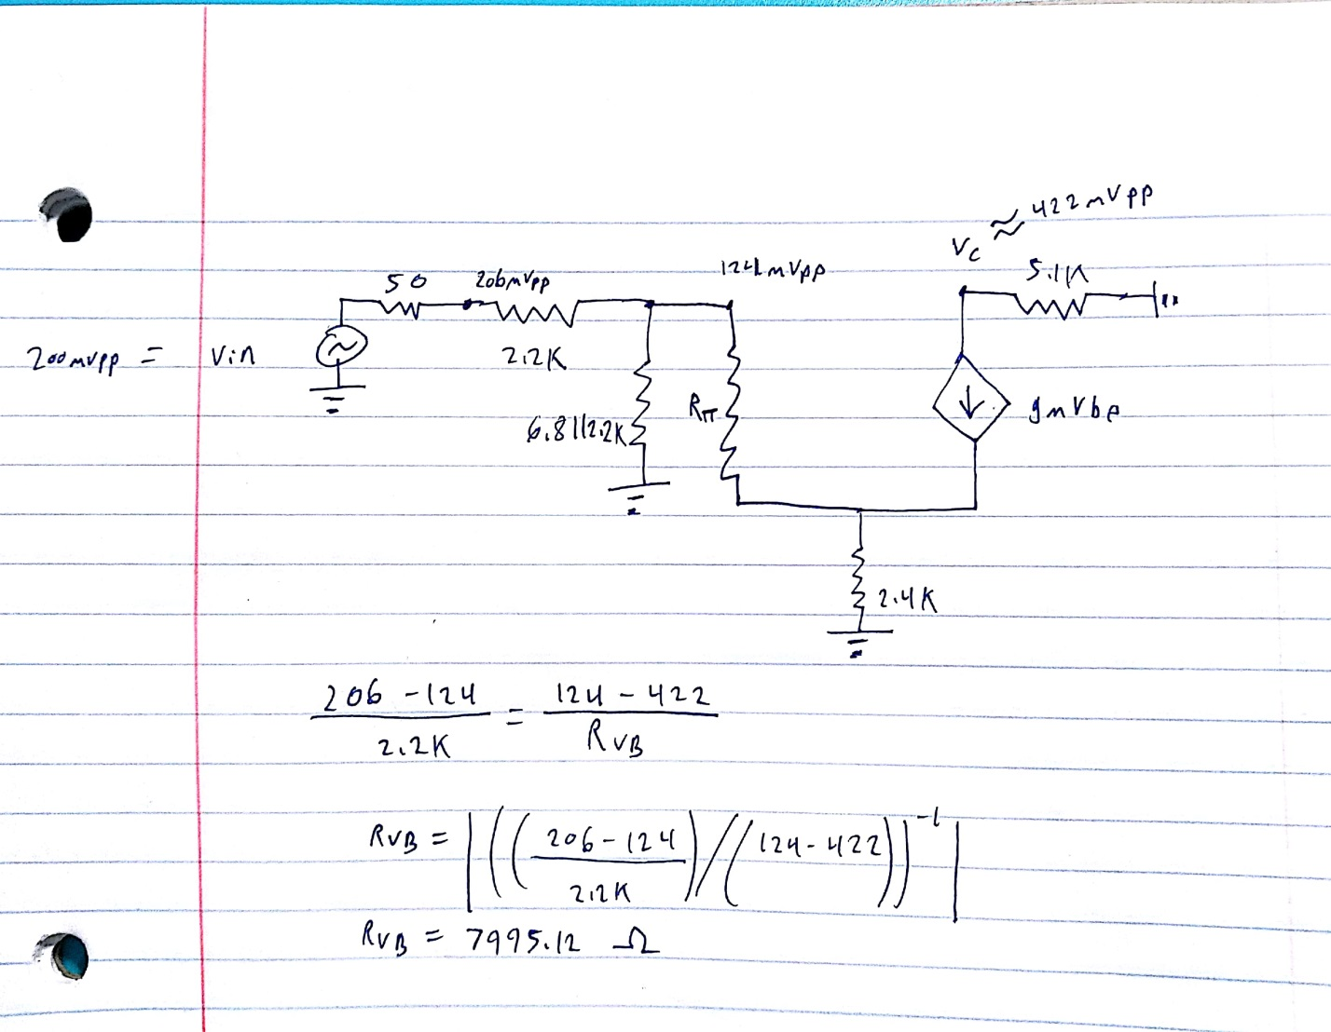

Input resistance at Vb = 7995.12 Ω

An estimate of the input resistance is produced by comparing the change in AC voltage swing across the 2200 Ω resistor to the change in AC voltage swing between the base and collector across a simplified input resistor RVb.

Part 2)

At 10khz without load, Vc AC = 422 mVpp

At 10khz with load, Vc AC = 310 mVpp

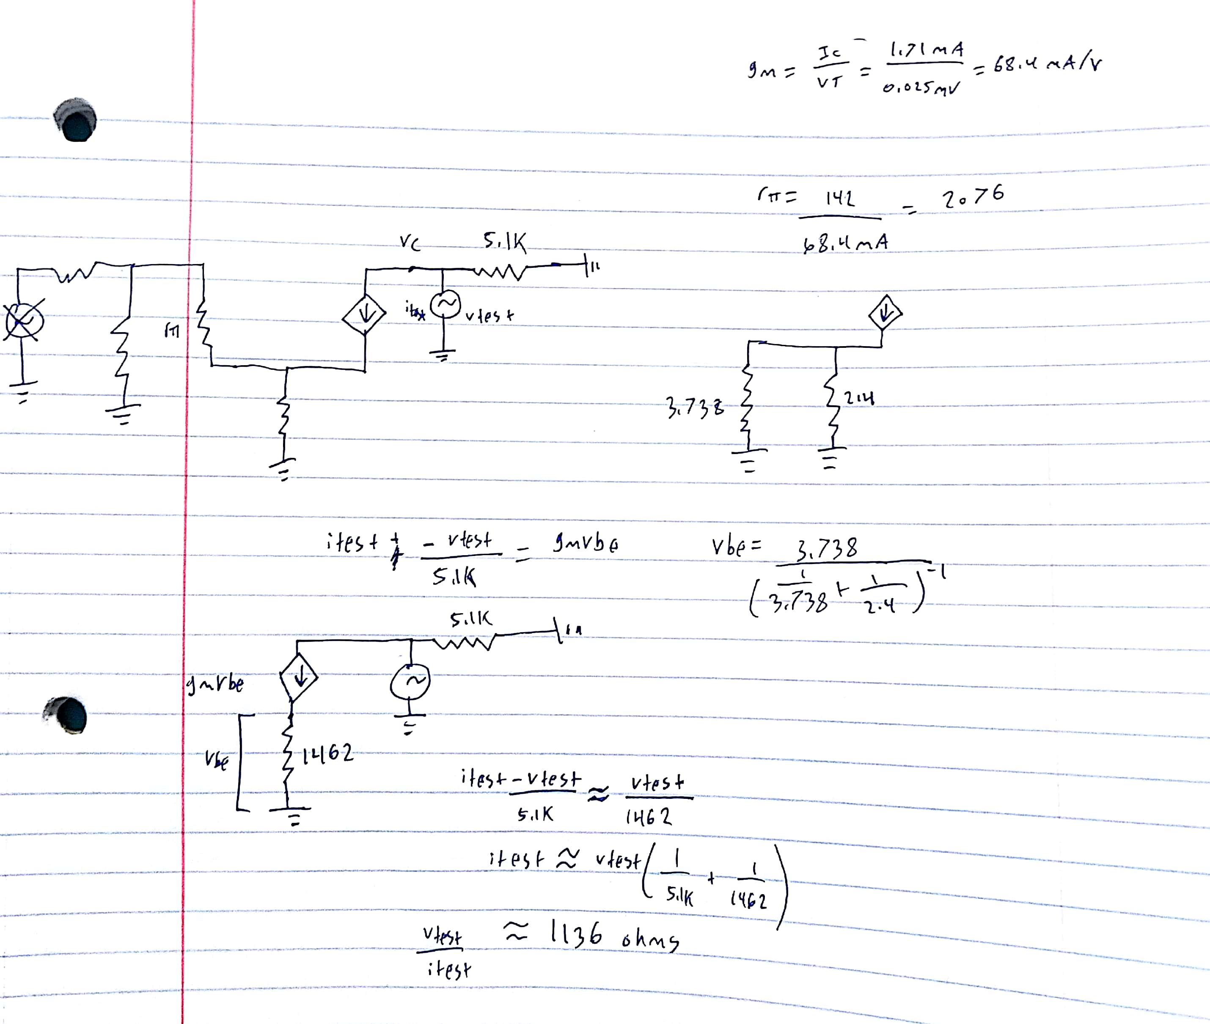

Output impedance = 1136 Ωs

Experiment 3)

|  |  |  |  |
| --- | --- | --- | --- |
| Vin | V1 | Vc | Gain |
| 200 mVpp | 204 mV | 5V | 24.51 |
| 300 mVpp | 288 mV | 6.78 V | 23.54 |

By adding the capacitor in parallel with the resistor emitter, the DC bias is unaffected and the emitter resistor is entirely bypassed in the small signal analysis. Because the capacitor acts as a short at high frequencies the emitter terminal is tied to ground at AC. This leads to a larger Vbe and thus a greater current through the transistor. This increases the amplifier gain by a factor greater than 10.

Gm = = = 68.4 mA/V

Rπ = = = 2076.02 Ω